

Practices for Secure Software Report

Table of Contents
Document Revision History 3
Client 3
Instructions 3
Developer 4
1. Algorithm Cipher 4
2. Certificate Generation 4
3. Deploy Cipher 4
4. Secure Communications 4
5. Secondary Testing 4
6. Functional Testing 4
7. Summary 4
8. Industry Standard Best Practices 4

Document Revision History

Version | Date | Author | Comments
1.0 | October 18, 2026 | Kadeem Abraham

Client



Developer
Kadeem Abraham

Algorithm Cipher

I recommend AES-256-GCM for encrypting Artemis Financial’s sensitive financial information. AES is a symmetric encryption algorithm, which means the same secret key is used to encrypt and decrypt information. AES-256 uses a 256-bit key and processes data in 128-bit blocks. GCM also provides an authentication tag that can help detect changes to encrypted information.
For this project’s checksum requirement, I implemented SHA-256. SHA-256 is a hash function rather than an encryption cipher. It produces a 256-bit digest, which is displayed as 64 hexadecimal characters. The same input produces the same checksum, while a change to the input produces a different result. Hashing does not use a decryption key and cannot be reversed like encryption.
Random numbers are important when generating encryption keys and other cryptographic values. Keys should be generated using a cryptographically secure random number generator. AES-GCM also requires a unique nonce for each encryption performed with the same key. Asymmetric cryptography uses a public and private key pair. In this project, the self-signed certificate uses an RSA key pair, while HTTPS uses TLS to protect communication between the browser and server.
Encryption has developed as older algorithms have become less secure. DES used a relatively short key, making it vulnerable to brute-force attacks. AES became a federal standard in 2001 and supports stronger key sizes. Older hash functions, including MD5 and SHA-1, have known collision weaknesses and should not be selected for security-sensitive checksum verification.
My implementation uses SHA-256 for the checksum and HTTPS for encrypted communication. AES-256-GCM is my recommendation for protecting confidential stored data; I did not implement separate AES file encryption in this application. A checksum must also be obtained through a trusted source, because an attacker who can replace both the data and its checksum could otherwise avoid detection.

Certificate Generation
I used Java Keytool to generate a self-signed certificate and an RSA key pair for the local application. The private key and certificate were stored in a PKCS12 keystore using the alias artemis. I then exported the public certificate as artemis-localhost.cer.
The exported certificate shows a 3,072-bit RSA public key and a SHA-256 with RSA signature. Its common name is localhost, and its Subject Alternative Name extension includes localhost and 127.0.0.1. These names match the local server used for testing. The certificate is valid from October 19, 2026, through October 19, 2027.
I trusted the certificate locally so that my browser could verify the connection without displaying a certificate warning. This self-signed certificate is appropriate for the classroom demonstration. A production application would require an appropriate trusted certificate and secure management of its private key.

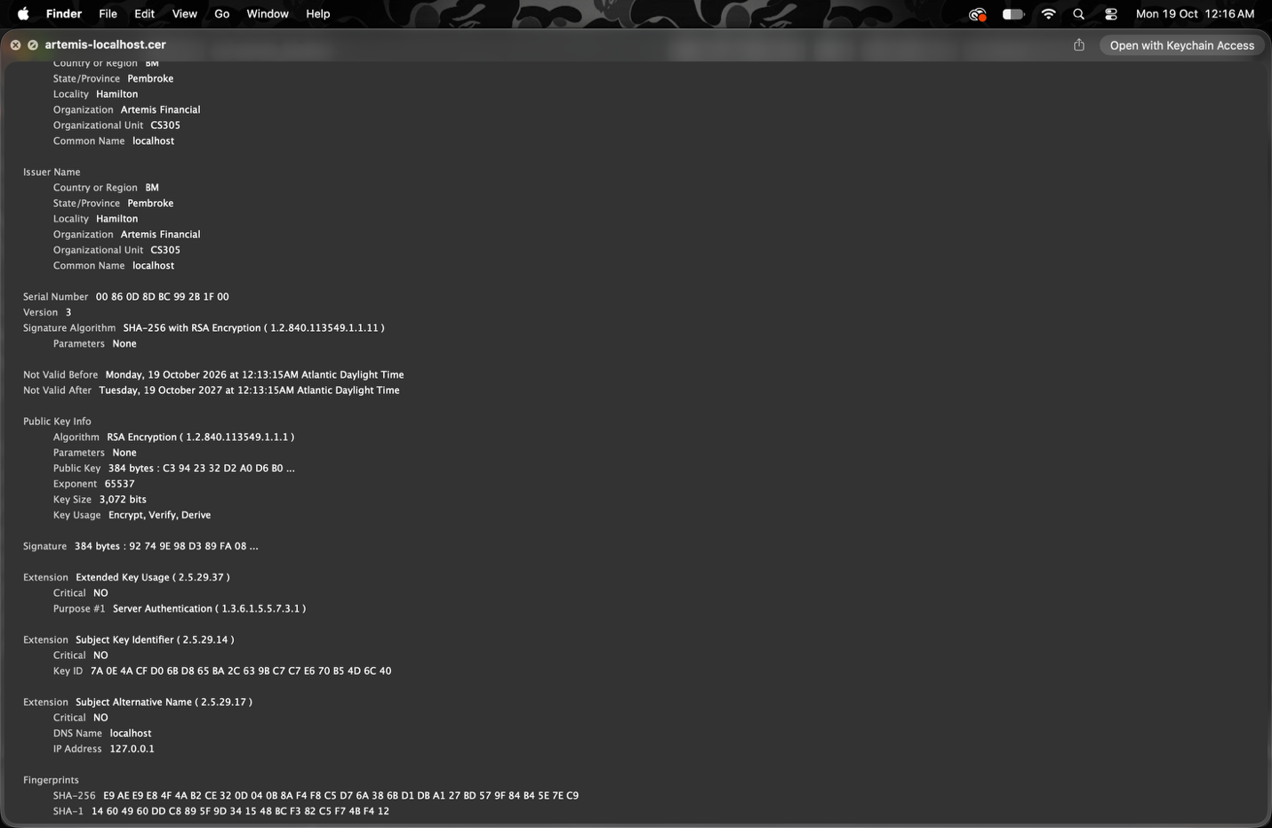

Deploy Cipher
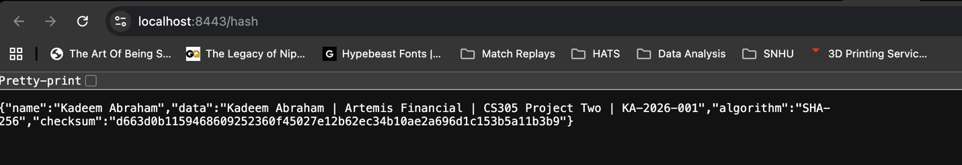

Secure Communications
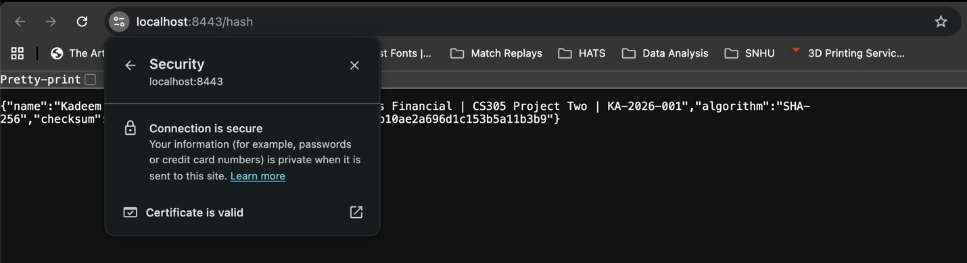

Secondary Testing
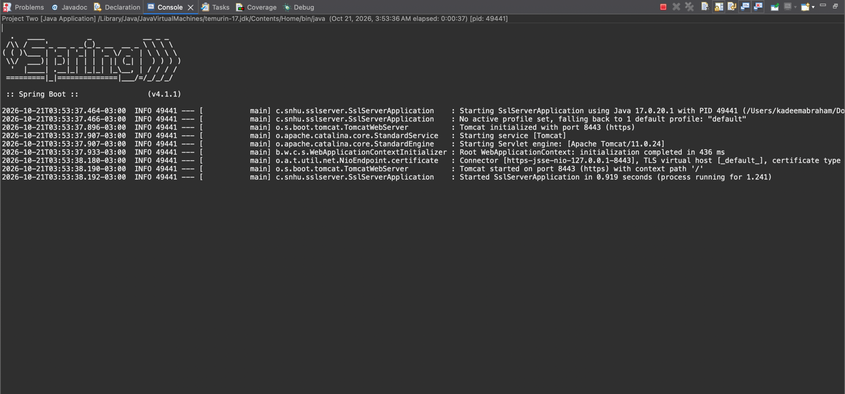
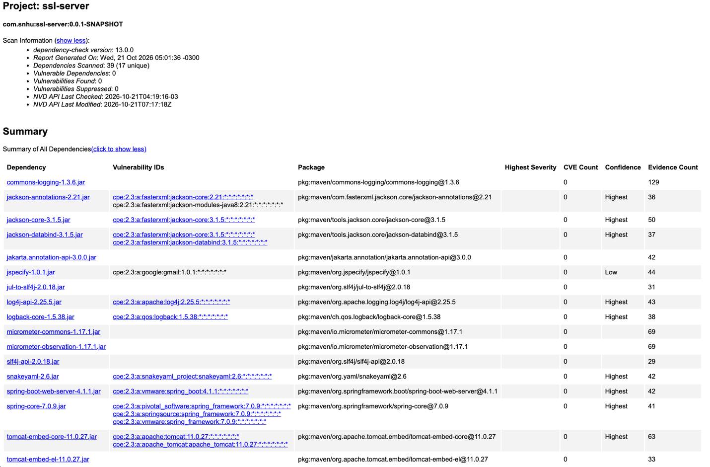

Functional Testing
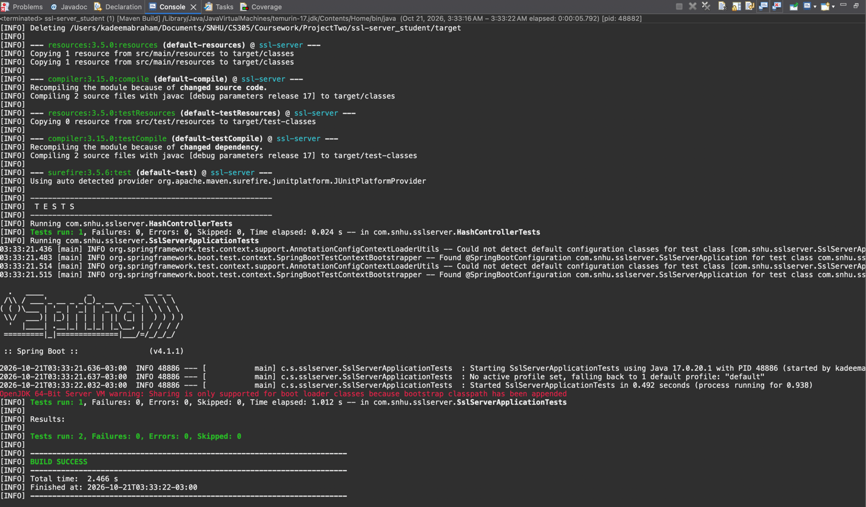
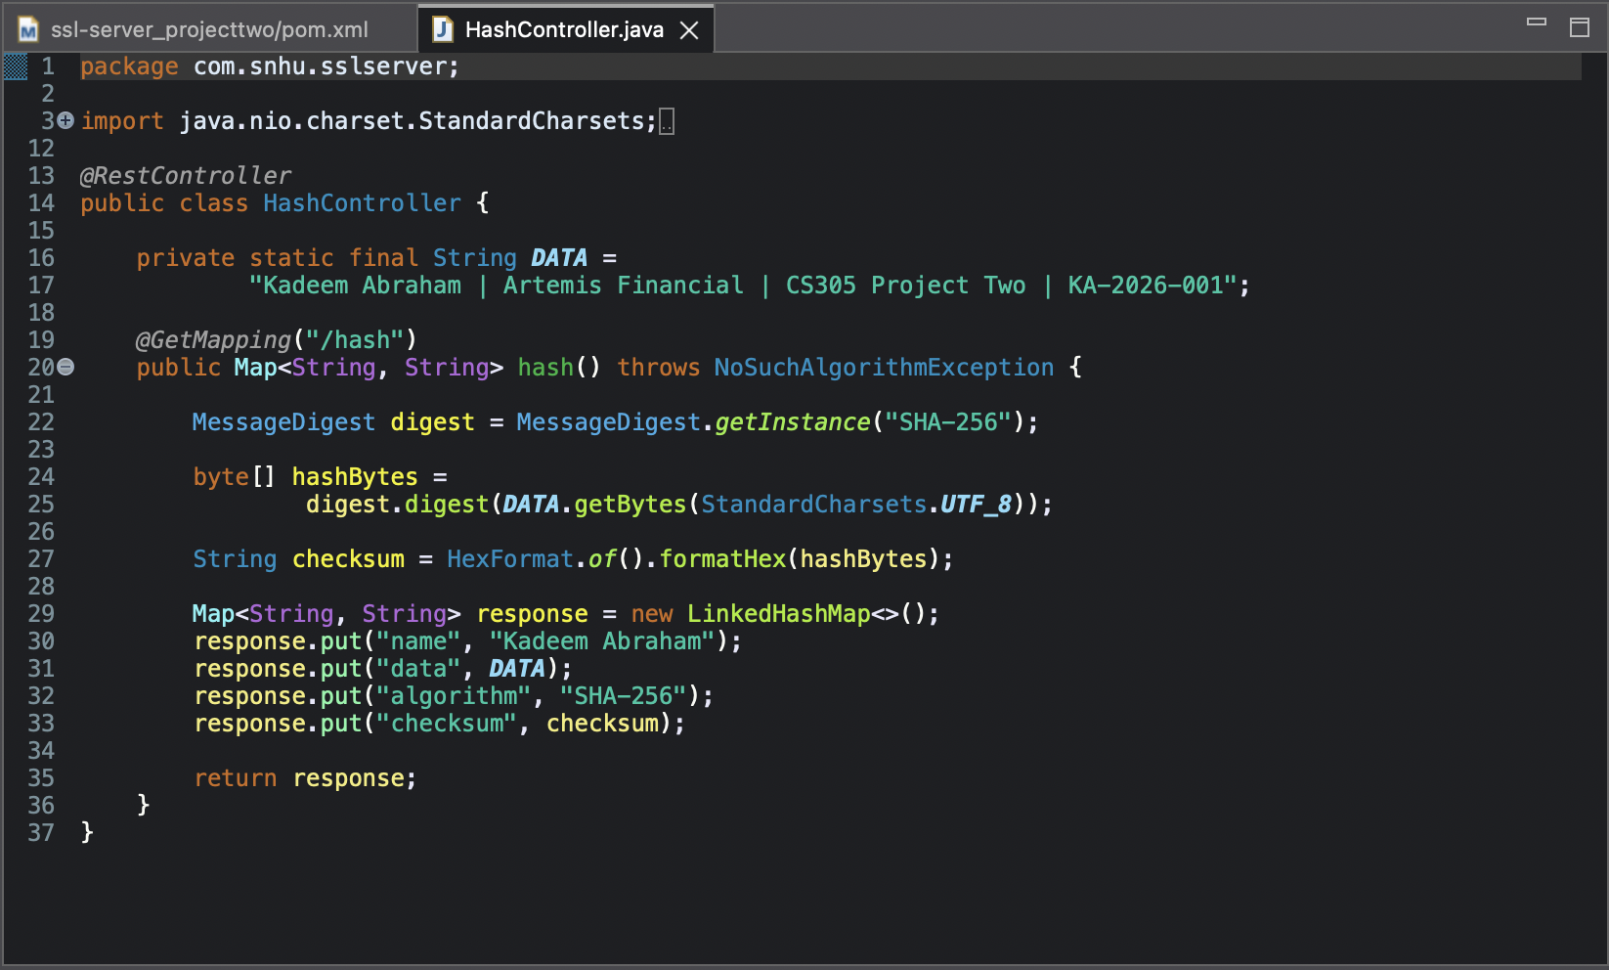

Summary

I refactored the starter application by adding SHA-256 checksum functionality and configuring HTTPS communication. I generated a self-signed certificate, exported its public certificate, and connected the application to its PKCS12 keystore. I also updated dependencies and used automated tests and Dependency-Check to evaluate the changes.
These changes address several areas in the vulnerability assessment process flow. Architecture review helped me understand the application and its dependencies. Cryptography was addressed through checksum generation and certificate configuration. Client/server security was addressed by enabling HTTPS and verifying the browser connection. API interactions and code quality were addressed by using established Java and Spring features. Input validation had a limited scope because the demonstration endpoint uses a fixed string instead of accepting external input.
The dependency remediation process reduced the reported findings from 40 to 17, then to 11, and finally to zero. The final scan identified no vulnerable dependencies, and no findings were suppressed. This process showed me the importance of reviewing scan results, updating affected components, and repeating security testing after changes. Continued updates and testing will still be necessary as new vulnerabilities are discovered.

Industry Standard Best Practices

I applied secure coding practices by using established cryptographic libraries instead of creating my own hashing algorithm. I used SHA-256 for checksum generation, UTF-8 for consistent input encoding, and HTTPS to protect communication. I also kept the keystore password outside the source code and limited the demonstration server to the local computer.
To maintain the application’s security, I reviewed dependency findings, updated affected libraries, and repeated testing after changes. I kept the application launcher and checksum controller separate so that the code was easier to understand and review. I did not suppress findings simply to make the report appear clean.
These practices are valuable to Artemis Financial because the company handles sensitive financial information. Secure development can reduce the chance of data exposure, service disruption, and expensive repairs. It also helps protect customer trust and the company’s reputation. Security requires continued maintenance, including dependency updates, certificate renewal, testing, and review of new vulnerabilities.

